Problem 1: Balance sheet
Pearl Street Bikes provides the following year-end account balances on December 31, 2024:
 | Debit | Credit
Cash | $10,800
Common stock |  | $25,000
Prepaid insurance | 750
Office supplies | 150
Inventory | 12,500
Cost of goods sold | 2,500
Accounts payable |  | 2,000
Supply expense | 400
Depreciation expense | 450
Equipment | 15,000
Accumulated depreciation |  | 5,400
Accounts receivable | 2,000
Revenue |  | 4,500
Gain from disposal of equipment |  | 100
Retained Earnings (1/1/2024) |  | 5,000
Unearned revenue |  | 2,800
Insurance expense | 250

Other info:
- On December 31, 2024, the company declared dividends of $50, but did not pay (This is not included in above accounts).
- The company is subject to a 30% income tax rate. If taxes are owed, the company will pay them in March 2025.
- The unearned revenue is related to goods to be delivered in June 2025.
Prepare a balance sheet for the current year.

1) | Div Declared $50 (but not paid)
 | Ret Earn (B-E) |  | 50
 | Div Payable (B-L) |  |  | 50
2) | Income Statement  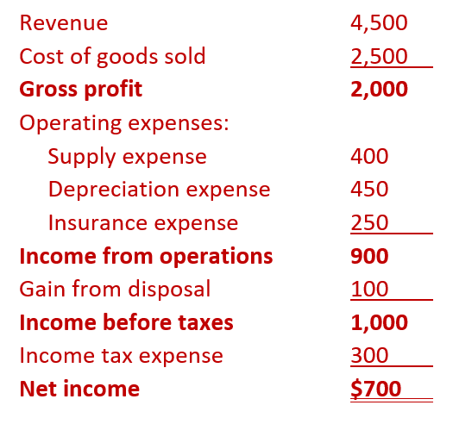
3) | Taxes
 | Tax Exp (I-E) |  | 300
 |  | Taxes Payable (B-L) |  | 300
4) | Retained Earn
 | Beg | 5,000
 | + NI | 700
 | - Div Dec | -50
 | End | 5,650
Assets |  | Liabilities
Cash | 10,800 | Accounts Payable | 2,000
Accounts Receivable | 2,000 | Unearned Revenue | 2,800
Inventory | 12,500 | Dividend Payable | 50
Office Supplies | 150 | Tax Payable | 300
Prepaid Insurance | 750 | Total Current Liabilities | 5,150
Total Current Assets | 26,200
 |  | No Long-Term Liabilities | $0
PP&E
Equipment 15,000 |  | Total Liabilities | 5,150
Less: Accum Dep (5,400) | 9,600
 |  | Stockholders’ Equity
Total Assets | $35,800 | Common stock | 25,000
 |  | Retained earnings | 5,650
 |  | Total Stockholders’ Equity | 30,650
 |  | Total Liab & SE | $35,800

Bonus Problem (Discontinued Operations)
Rocky Ridge Outdoor Gear, Inc. reported the following results for the year ended December 31, 2024 (all amounts in $000s). The discontinued camping equipment division details are below.
- Income from continuing operations before tax: $500
- Loss from operations of the discontinued camping equipment division, before tax: $80
- Loss on sale of the camping equipment division, before tax: $40
- Tax rate: 30%
Required:
Prepare a partial income statement for Rocky Ridge Outdoor Gear, Inc. for the year ended December 31, 2024. The statement should begin with Income from Continuing Operations (before tax) and end with Net Income. Show negative amounts as

Income from continuing operations, before tax $500,000
Taxes (30%) (150,000)
Income from continuing operations, after tax 350,000
Discontinued Operations
Loss from operations of discontinued division, net of tax (56,000)
Loss on sale of discontinued division, net of tax (28,000)
Net Income 266,000

Disc Ops calculations
- Discontinued operations:
  - Operating loss: 80 pre-tax → net = 80 × (1 − 0.30) = 56
  - Loss on sale: 40 pre-tax → net = 40 × (1 − 0.30) = 28

